Stop Lab Cuts Social Toolkit

Campaign Launch Social

Social Copy | Graphic
We launched the #StopLabCuts campaign to raise awareness of impending Medicare cuts to lab tests scheduled to resume in January & the negative impact they could have on care delivery, the clinical lab infrastructure, and diagnostic innovation. Learn more: https://bit.ly/3ITfBMV. | 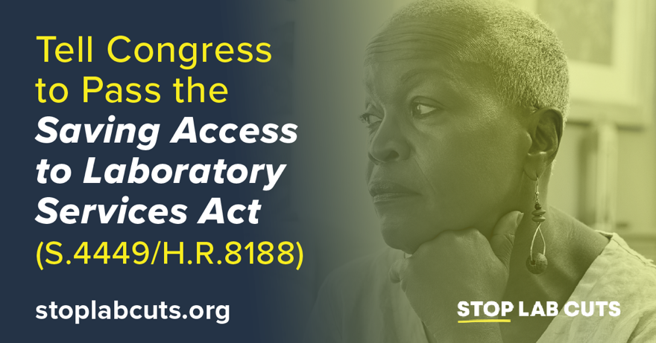
America needs a strong clinical laboratory infrastructure to support the delivery of routine patient care. That’s why we’ve launched the #StopLabCuts campaign, urging Congress to enact the Saving Access to Laboratory Services Act this year. Learn more: https://stoplabcuts.org/. | 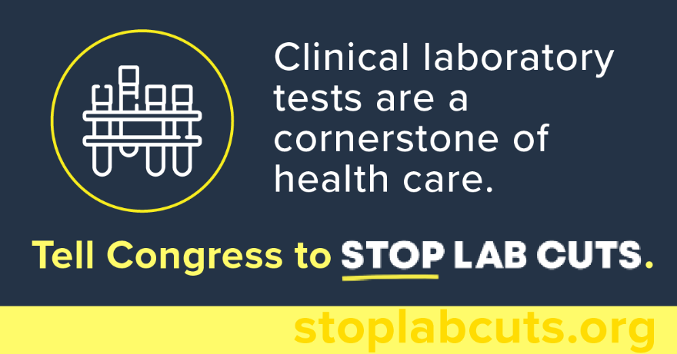

Patient Impact Social

Social Copy | Graphic
#DYK? Scheduled #Medicare reimbursement cuts could compromise access to many of the clinical laboratory tests used to diagnose, monitor, and manage autoimmune diseases for America’s seniors. Learn how we can #StopLabCuts: https://stoplabcuts.org/. | 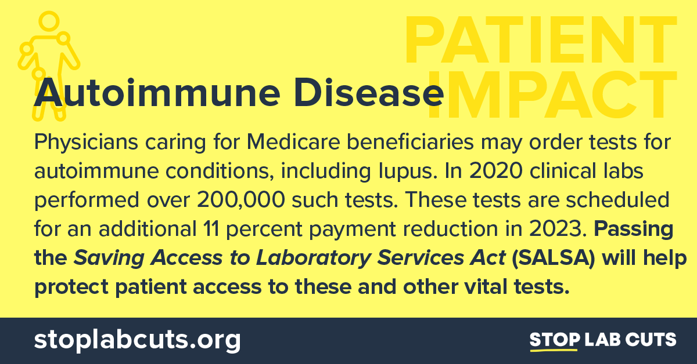
Without Congressional action, reimbursement for routine laboratory tests used to diagnose and monitor serious chronic conditions, including diabetes, will be cut an additional 9-14% in 2023. Tell Congress to #StopLabCuts: https://stoplabcuts.org/. | 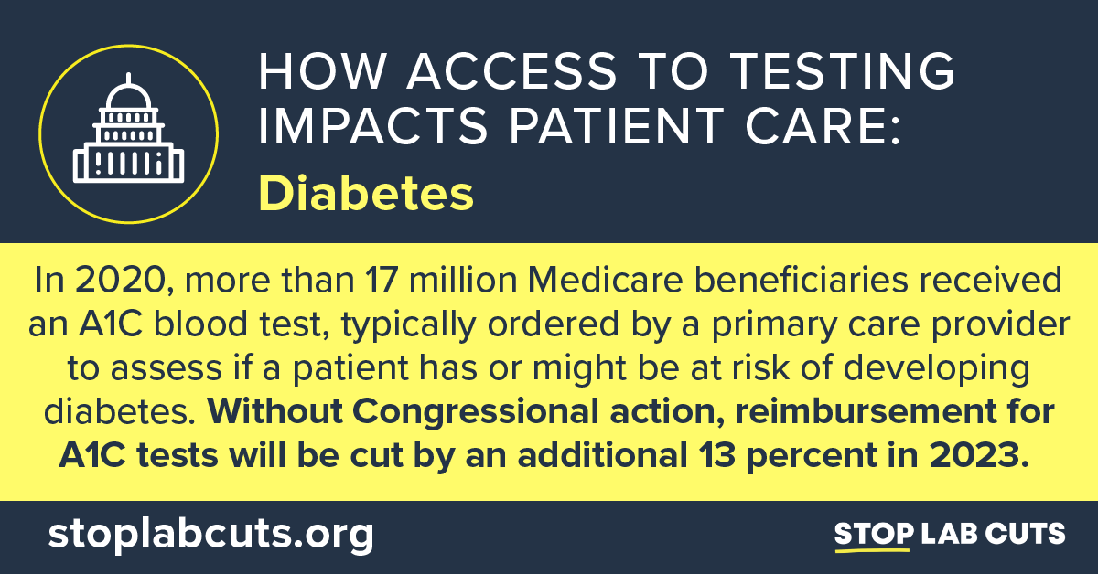
In 2020, over 28 million tests were ordered to diagnose heart disease. Congress can now protect patients’ access to these tests and more by addressing scheduled cuts to #Medicare reimbursement. Learn more about our efforts to #StopLabCuts: https://stoplabcuts.org/. | 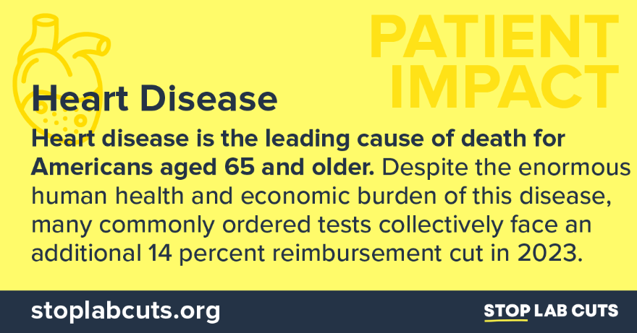
Unless Congress steps in, reimbursement for lab tests used to diagnose chronic kidney disease will decrease by an additional 14% this January, making it potentially more difficult for patients to access the tests they need. Tell Congress to #StopLabCuts: https://stoplabcuts.org/. | 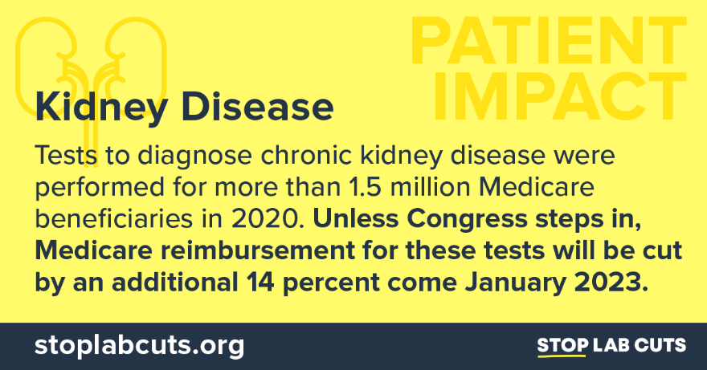
#DYK? In 2020, physicians caring for Medicare beneficiaries ordered nearly 90,000 tests to diagnose leukemia and hereditary breast and colon cancer. For seniors battling cancers, access to routine testing can be lifesaving. Learn how we can #StopLabCuts: https://stoplabcuts.org/. | 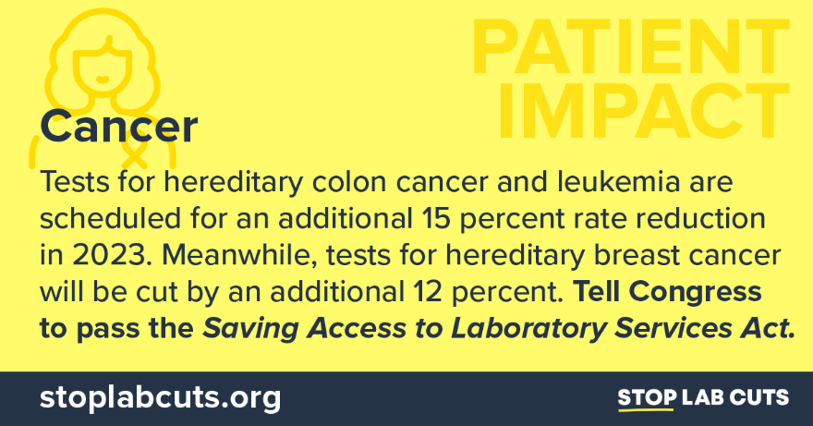
Routine testing helps improve patient outcomes by identifying diseases at an earlier stage. New #PAMA cuts to laboratory services are scheduled to go into effect in January and could harm patient access to care. Tell Congress to #StopLabCuts. https://stoplabcuts.org/. | 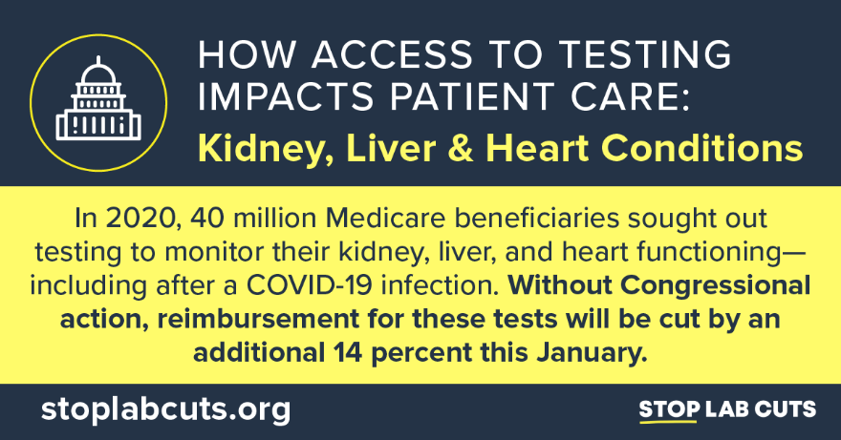
Leading patient organizations have called on Congress to #StopLabCuts and protect access to hundreds of commonly ordered laboratory tests. Without Congressional action, impending #PAMA cuts may limit access to the tests patients depend on. Read more: https://nclnet.org/salsa-2022/. | 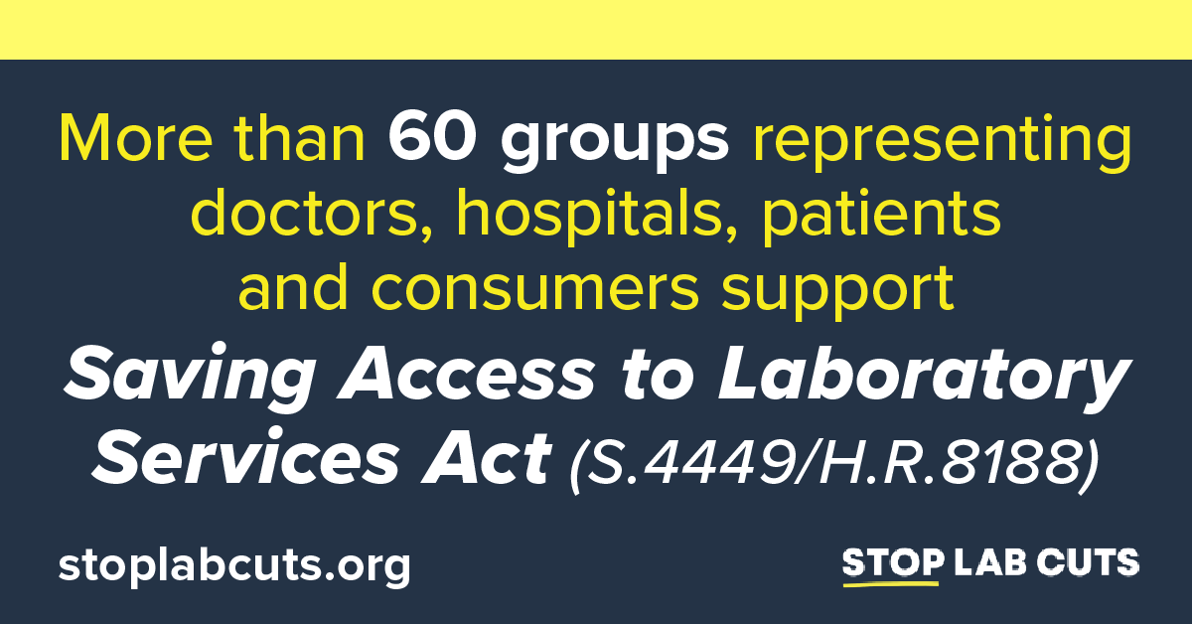
#SALSA has widespread support among doctors, hospitals, and patients. Recently, 37 patient groups and 26 provider groups sent letters urging Congress to #StopLabCuts. Congressional action is needed now to protect patient access to care. Read more: https://nclnet.org/salsa-2022/. | 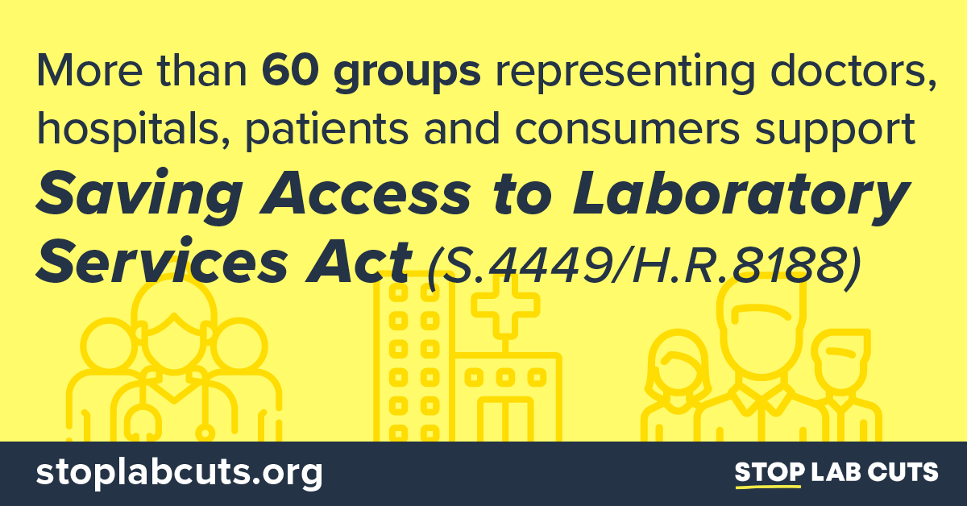

Evergreen SALSA Social

.@POTUS signed the CHIPS Act into law to invest in future technologies. Now, it’s time for Congress to pass the SALSA! The Saving Access to Laboratory Services Act (SALSA) will help protect patient access to vital lab tests. Learn more: https://stoplabcuts.org/.

What’s better than pairing the CHIPS Act with SALSA? SALSA – the Saving Access to Laboratory Services Act – will support strong clinical laboratory infrastructure to protect patient and public health and innovation in tomorrow’s diagnostics. Learn more: https://stoplabcuts.org/.

Passing the Saving Access to Laboratory Services Act would reform #PAMA, protecting access to essential clinical laboratory tests so that our nation’s seniors can live their fullest and healthiest lives. Learn more: https://stoplabcuts.org/.

New #PAMA cuts could undermine lab infrastructure needed for delivery of routine care, public health while dampening innovation. The Saving Access to Laboratory Services Act will help protect millions of seniors’ access to vital lab services: https://stoplabcuts.org/.

Routine tests play a critical role in health care and most cost between $5 and $12. Without congressional action, reimbursement for these tests will be cut by up to 15 percent in 2023. Learn more and tell Congress to #StopLabCuts: https://stoplabcuts.org/.

#DYK? Medicare reimbursement cuts resulting from #PAMA may weaken our clinical laboratories’ investment in the next generation of diagnostic tests, including those that diagnose cancer. Learn more and help #StopLabCuts: https://stoplabcuts.org/.

#PAMA has resulted in lab payment cuts totaling close to $4 billion. Congress must act and pass the Saving Access to Laboratory Services Act to ensure that America’s seniors maintain access to lifesaving clinical laboratory tests. Learn more: https://stoplabcuts.org/.

#DYK? Scheduled Medicare reimbursement cuts could limit access to many of the clinical laboratory tests used to diagnose, monitor, prevent, and manage common diseases for more than 50 million seniors. Learn more and help #StopLabCuts: https://stoplabcuts.org/.

Passing the Saving Access to Laboratory Services Act would reform #PAMA and help protect access to the most common laboratory tests that America’s seniors depend on. Learn more: https://stoplabcuts.org/.

New #PAMA cuts could undermine laboratory infrastructure essential for day-to-day care and responding to public health emergencies while also stifling investments for innovative new screening and diagnostic tests. Tell Congress to #StopLabCuts: https://stoplabcuts.org/.

A Complete Blood Count (CBC) test is used to detect, monitor, and manage a range of diseases including infections, heart disease, autoimmune conditions, and certain cancers. Tell Congress to pass SALSA and #StopLabCuts to critical tests like the CBC: https://stoplabcuts.org/.

A Complete Metabolic Panel is often part of routine care to detect diseases like hypertension, diabetes, and kidney disease. Clinicians rely on this test every day to care for patients. Tell Congress to protect access to lab tests and #StopLabCuts: https://stoplabcuts.org/.

Evergreen SALSA Social Graphics

