Stop Lab Cuts Social Toolkit

Campaign Social

Social Copy | Graphic
Impending Medicare cuts to lab tests threaten patient access to care. Congress must take action by passing #SALSA before the end of this year: https://bit.ly/3ITfBMV. | 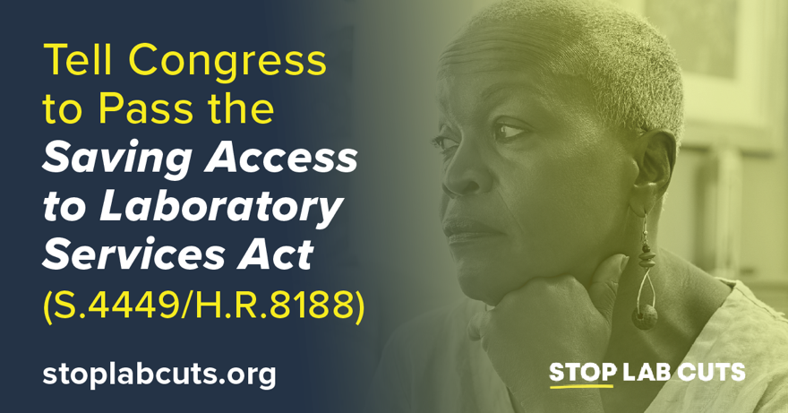
America needs a strong clinical laboratory infrastructure to support the delivery of routine patient care. That’s why we’re urging Congress to #StopLabCuts by enacting the Saving Access to Laboratory Services Act by the end of this year: https://stoplabcuts.org/. | 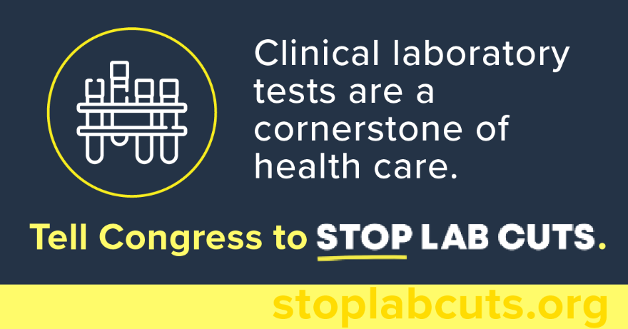
Leading patient organizations are calling on Congress to #StopLabCuts. Without Congressional action, impending #PAMA cuts may limit access to the tests patients rely on. Tell Congress to act now: https://nclnet.org/salsa-2022/. | 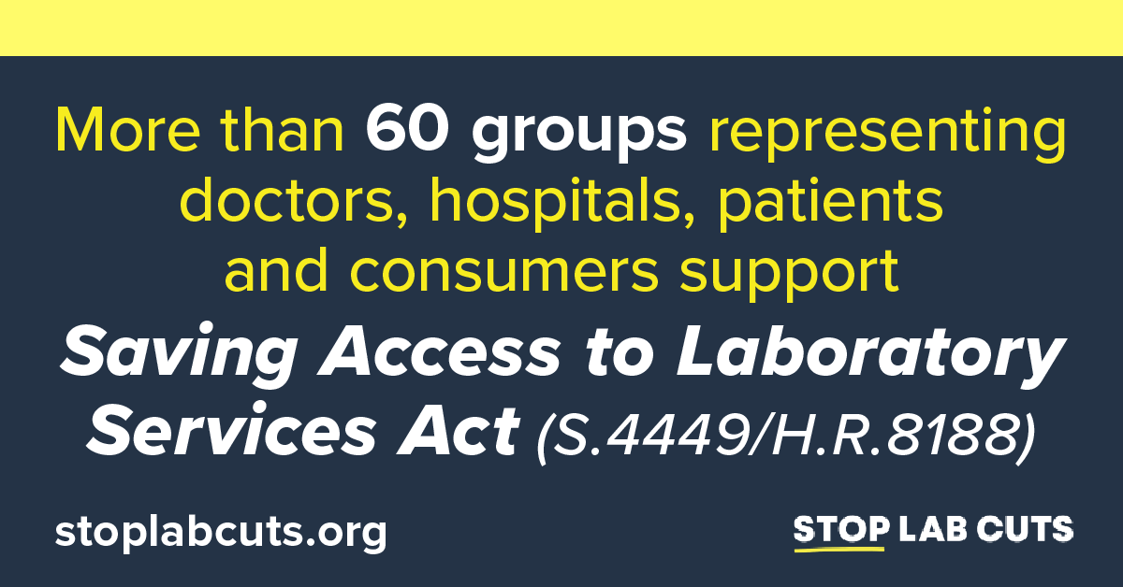

#SALSA has strong support among doctors, hospitals, and patients. Recently, 37 patient groups and 26 provider groups sent letters urging Congress to #StopLabCuts. Congressional action is needed now to protect patient access to care: https://nclnet.org/salsa-2022/. | 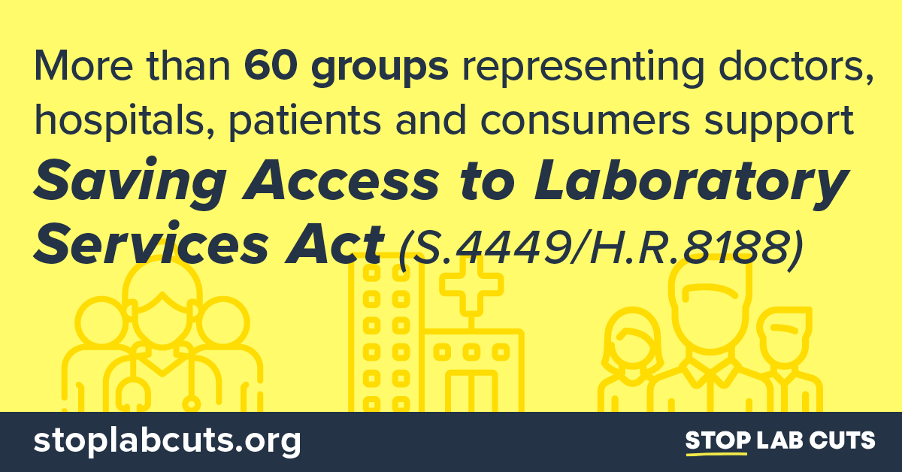
New #PAMA cuts could undermine laboratory infrastructure essential for day-to-day care and responding to public health emergencies while stifling investments in innovative new screening and diagnostic tests. Tell Congress to enact #SALSA now: https://stoplabcuts.org/. | 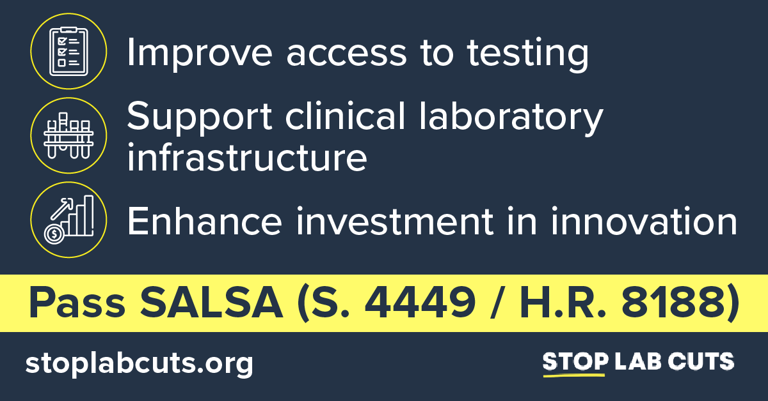
Unless Congress steps in, reimbursement for lab tests used to diagnose and monitor serious chronic conditions will face significant cuts this coming January. Tell Congress to #StopLabCuts and enact #SALSA before the end of this year: https://stoplabcuts.org/ | 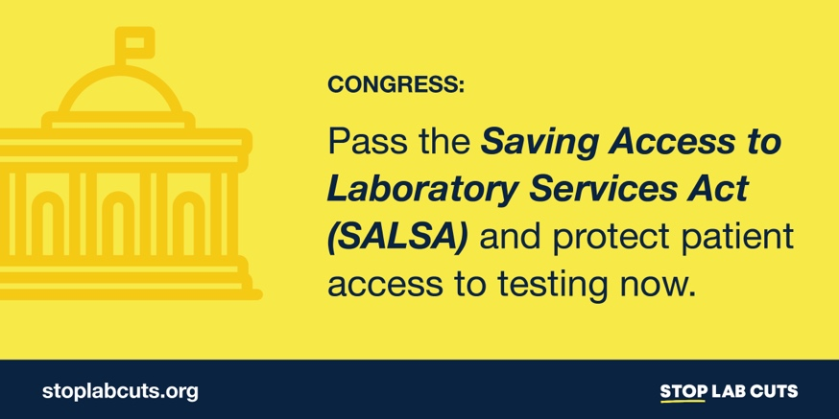
Scheduled #Medicare reimbursement cuts could compromise access to clinical laboratory tests used to diagnose, monitor, and manage chronic conditions for America’s seniors. To protect patient care, Congress must #StopLabCuts and pass #SALSA this year: https://stoplabcuts.org/ | 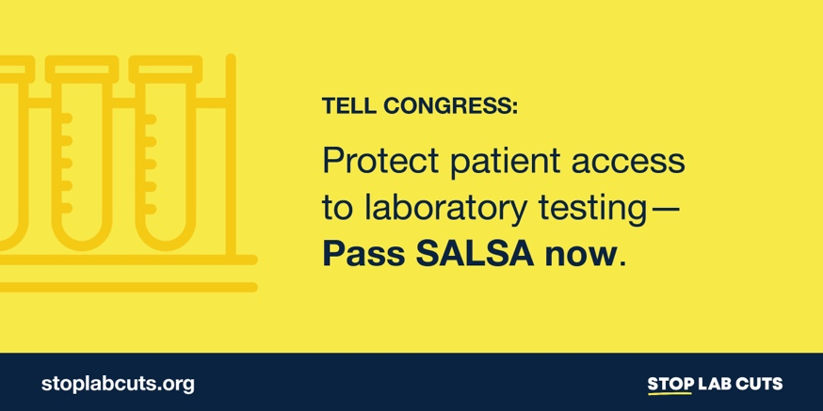

Patient Impact Social

Social Copy | Graphic
#DYK? Scheduled #Medicare reimbursement cuts could compromise access to many of the clinical laboratory tests used to diagnose, monitor, and manage autoimmune diseases for America’s seniors. Tell Congress to #StopLabCuts and pass #SALSA: https://stoplabcuts.org/. | 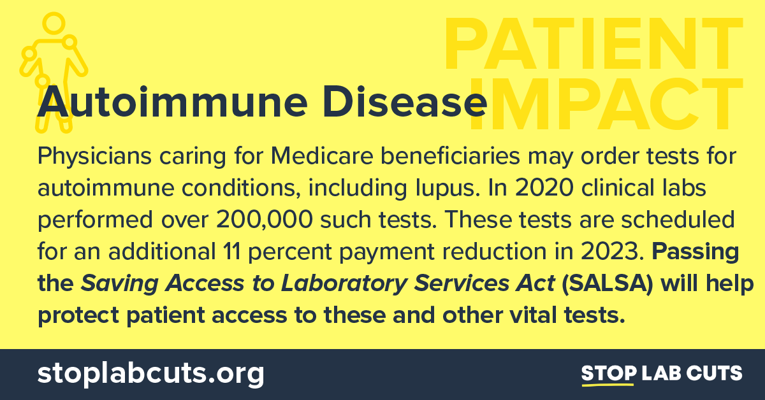
Without Congressional action, reimbursement for routine laboratory tests used to diagnose and monitor serious chronic conditions, including diabetes, will be cut an additional 9-14% in 2023. Tell Congress to #StopLabCuts and pass #SALSA now: https://stoplabcuts.org/. | 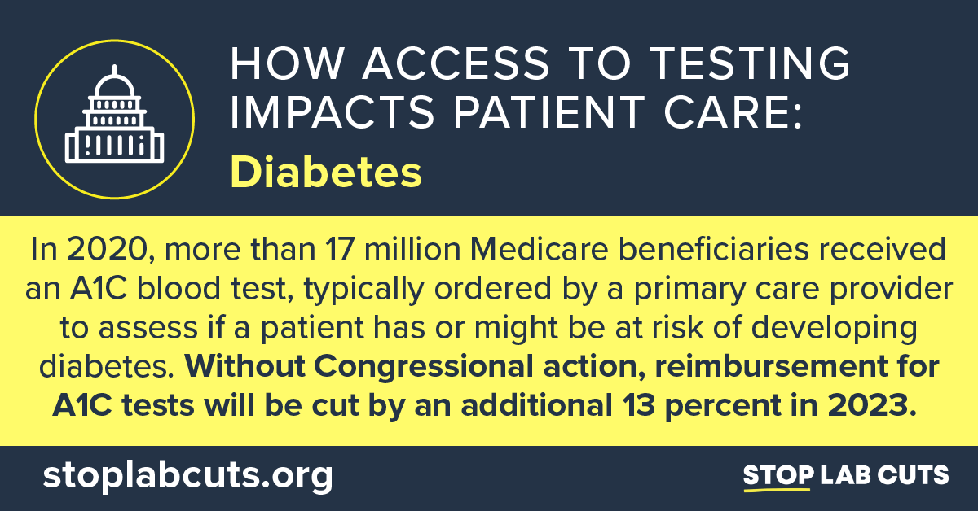
In 2020, over 28 million tests were ordered to diagnose heart disease. Congress can now protect patients’ access to these tests and more by addressing scheduled cuts to #Medicare reimbursement and passing #SALSA before the end of this year: https://stoplabcuts.org/. | 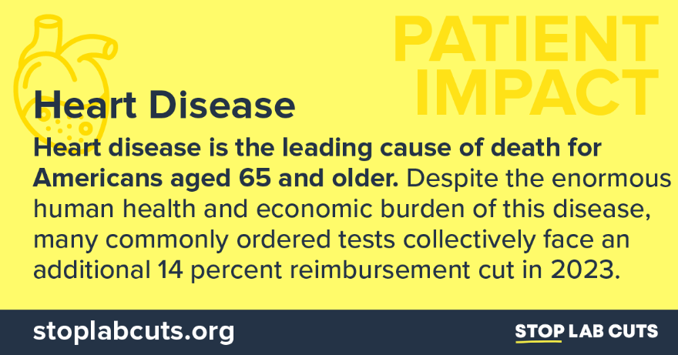
Unless Congress steps in, reimbursement for lab tests used to diagnose chronic kidney disease will decrease by an additional 14% this January. Tell Congress to #StopLabCuts and enact #SALSA before the end of this year: https://stoplabcuts.org/. | 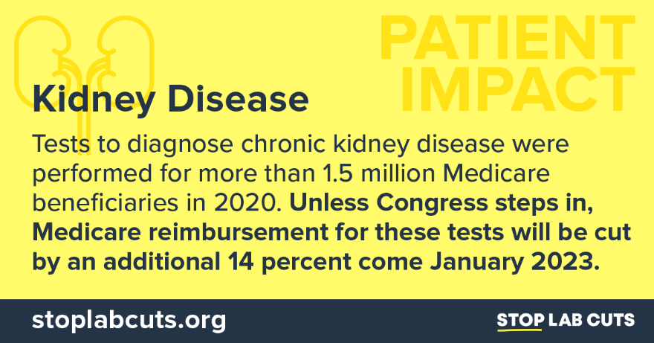
#DYK? In 2020, physicians caring for Medicare beneficiaries ordered nearly 90,000 tests to diagnose leukemia and hereditary breast and colon cancer. To protect patient care, Congress must #StopLabCuts and pass #SALSA now: https://stoplabcuts.org/. | 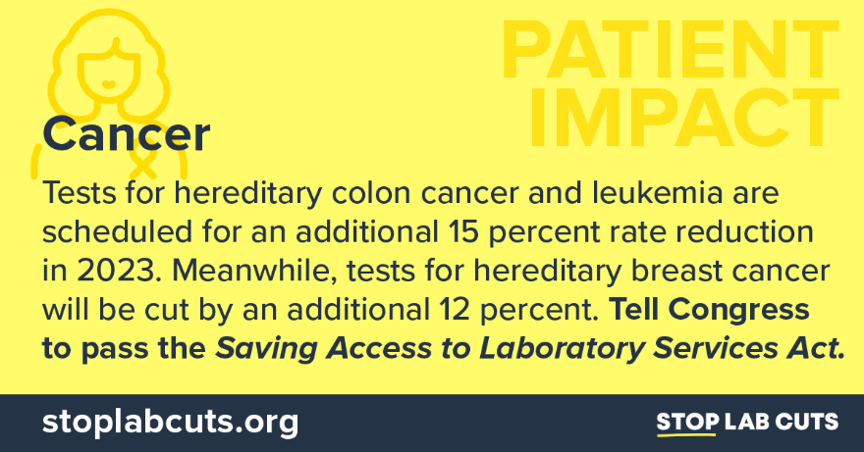
Routine testing helps improve patient outcomes by identifying diseases at an earlier stage. #PAMA cuts to laboratory services are scheduled to go into effect in January and could harm patient access to care. Tell Congress to pass #SALSA now: https://stoplabcuts.org/. | 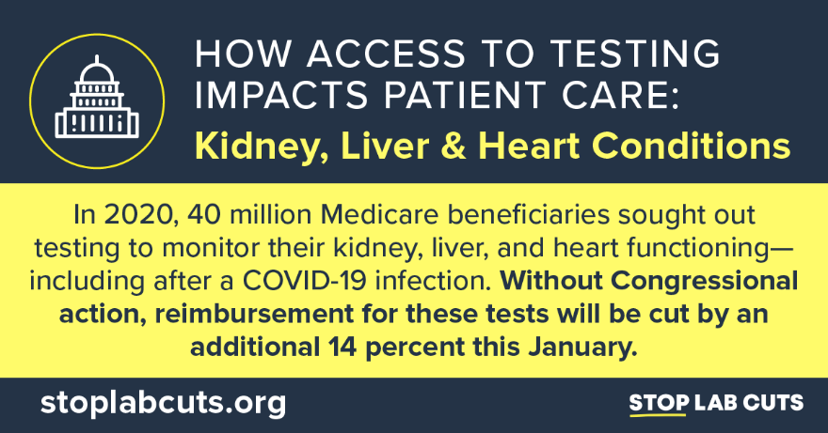

Evergreen SALSA Social

Passing the Saving Access to Laboratory Services Act would reform #PAMA, protecting access to essential clinical laboratory tests so that our nation’s seniors can live their fullest and healthiest lives. Learn more and tell Congress to pass #SALSA now: https://stoplabcuts.org/.

Routine tests play a critical role in health care and most cost between $5 and $12. Without congressional action, reimbursement for these tests will be cut by up to 15 percent in 2023. Learn more and tell Congress to #StopLabCuts by enacting #SALSA now: https://stoplabcuts.org/.

#DYK? Medicare reimbursement cuts resulting from #PAMA may weaken our clinical laboratories’ investment in the next generation of diagnostic tests, including those that diagnose cancer. Tell Congress to pass #SALSA before the end of this year: https://stoplabcuts.org/.

#DYK? Scheduled Medicare reimbursement cuts could limit access to many of the clinical laboratory tests used to diagnose, monitor, prevent, and manage common diseases for more than 50 million seniors. Urge Congress to #StopLabCuts by passing #SALSA now: https://stoplabcuts.org/.

Passing the Saving Access to Laboratory Services Act would reform #PAMA and help protect access to the most common laboratory tests that America’s seniors depend on. Learn more and tell Congress to act now: https://stoplabcuts.org/.

A Complete Blood Count (CBC) test is used to detect, monitor, and manage a range of diseases including infections, heart disease, autoimmune conditions, and certain cancers. Tell Congress to pass #SALSA and #StopLabCuts to critical tests like the CBC: https://stoplabcuts.org/.

A Complete Metabolic Panel is often part of routine care to detect diseases like hypertension, diabetes, and kidney disease. Clinicians rely on this test every day to care for patients. Tell Congress to protect access to lab tests and pass #SALSA now: https://stoplabcuts.org/.

